**Ques 1 : Creating Microservices for account and loan**

**Code :**

**--AccountController.java**

package com.cognizant.account.controller;

import org.springframework.web.bind.annotation.*;

import java.util.Map;

@RestController

@RequestMapping("/accounts")

public class AccountController {

@GetMapping("/{number}")

public Map<String, Object> getAccount(@PathVariable String number) {

return Map.of(

"number", number,

"type", "savings",

"balance", 234343

);

}

}

**Output (Account Service)**

**URL:** <http://localhost:8080/accounts/00987987973432>

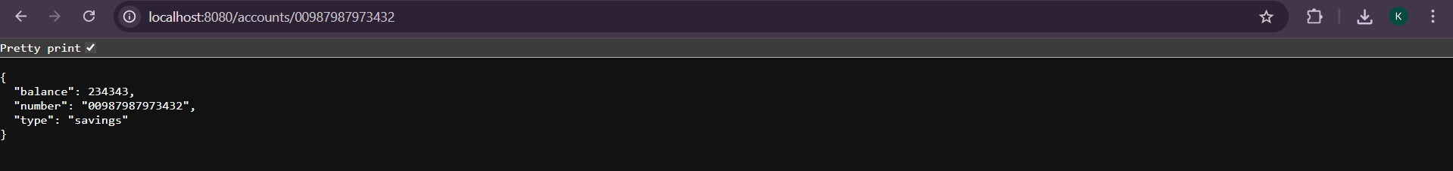

**--LoanController.java**

package com.cognizant.loan.controller;  
  
import org.springframework.web.bind.annotation.*;  
  
import java.util.Map;  
  
@RestController  
@RequestMapping("/loans")  
public class LoanController {  
  
 @GetMapping("/{number}")  
 public Map<String, Object> getLoan(@PathVariable String number) {  
 return Map.*of*(  
 "number", number,  
 "type", "car",  
 "loan", 400000,  
 "emi", 3258,  
 "tenure", 18  
 );  
 }  
}

**Output (Loan Service)**

**URL:** <http://localhost:8081/loans/H00987987972342>

